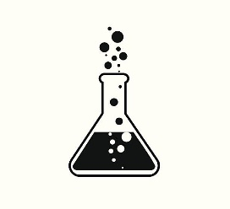
Lassiter Science Department
Extra Help Sessions
2019-2020

BIOLOGY/LIFE SCIENCES
The Biology department holds scheduled help sessions every Tuesday afternoon.
Please see teacher schedule for weekly room number.

Ryan Donaldson (Biology)
By appointment

Dayle Koester (Honors Biology, Honors Human Anatomy)
Mornings by appointment

Jennifer Mercure (Biology, AP Environmental Science)
Biology: Tuesdays 3:30 – 4:00, APES: By appointment

Alicia Rowan (Zoology, AP Biology)
Afternoons by appointment

Hillary Wilson (Biology, Zoology, STEM Honors Biology)
Monday through Friday 7:45 – 8:10

Kristie Wright (Honors Biology)
Monday through Friday 7:45 – 8:10
BIOMEDICAL SCIENCES
Marlena Lloyd (Biomedical Sciences)
Tuesday 7:30 – 8:15, Afternoons by appointment

Kelly MacArthur (Human Body Systems, Earth Systems)
Tuesday and Thursday 7:30 to 8:00

CHEMISTRY
Students can attend help sessions with any member
of the chemistry department for additional help.

Stephanie Day (Chemistry, STEM Chemistry)
Wednesday morning, Wednesday afternoon, ASE

Courteney Hinkson (Chemistry, Forensics)
Mornings by appointment, ASE, Wednesday 3:30 – 4:00

Jenny Lee (Chemistry, Honors Chemistry)
Monday through Friday 7:45-8:15, ASE

Halei Smith (Honors Chemistry, AP Chemistry)
Tuesday and Wednesday 7:45 – 8:15

PHYSICS
Jon Christopher (Physics, AP Physics C, Super Physics)
Mornings, By appointment

Ashley Kirby (Physics, AP Physics 1)
Mornings by appointment, ASE

Rodger Leduc (Physics)
Monday through Friday 7:00 – 8:00

Keelan Seabolt (STEM AP Physics 1, AP Physics 1)
Tuesday and Thursday 3:45 – 4:30

