Honors Film, TV, & Theatre I
Honors Dramatic Writing
Earn credit for Honors Literature & Composition IV and Fine Arts

Why This Class is Different

- You get to be weird – Write what you actually think about care about.
- Your voice matters. No one wants you to sound like a robot or textbook.
- Immediate feedback during peer workshops for most pieces.
- You leave with real work. A portfolio piece you’re proud of—not just test scores.

Skills You’ll Actually Use

- Pitching ideas
- Story structure
- Character development
- Dialogue that sounds like real people
- Collaboration & workshop critique

Why Honors?

- Autonomy: more freedom & meaningful creative choices
- Rigor: high expectations for revision and polished final work.
- Professionalism: you’re treated like a writer, not a worksheet-completer.

Disclaimer: Creativity ≠ trauma or lore dumping. We write thoughtfully and intentionally
CHOOSE DRAMATIC WRITING DURING FALL REGISTRATION IN FEBRUARY!

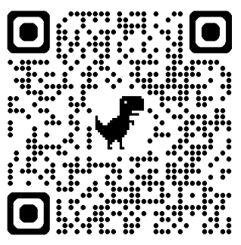
For additional information:

Student Voices

“This class finally allowed my intrusive thoughts to manifest in the physical realm.” – Elliot S.

“Even with dyslexia, I have found this class easy and fun. For a writer, this class, especially in a high school setting, is extremely relaxing and the community just in class is so inclusive.” – Sofia Y.

“This class doesn’t [make me] feel like my stories are insane and nonsensical.” – Cedar P.

“As someone who does both [AP Lit & Dramatic Writing], this writing never feels like a chore.” – Lauren P.

“I’m allowed to write the way I’ve desired to my whole life by using my own voice and ideas.” – Ashlyn L.

“I appreciate how you can have creative freedom and let your thoughts flow instead of being traditionally conformed.” – Claire M.

“I have laughed more in this class than in all my time in school. The work never feels like a chore – it’s exciting and fun. Easily the best class at Lassiter.” – Elena W.

“Every day is a new adventure! You get to ransack your mind palace.” – Anonymous

You can also email Dr. Moser at alora.moser@cobbk12.org.

